Logo%20Main%20200

**Boston University**

**Electrical & Computer Engineering**

**EC463 Capstone Senior Design Project**

**Problem Definition and Requirements Review**

Running Safety Device



Submitted to

Alan Pisano

Boston University

(617) 353 6264

apisano@bu.edu



by

Team 22

Running Safety Team

Team Members

Thomas Cimino tpcimino@bu.edu

Zexing Gao zexing@bu.edu

Cong Han hancong@bu.edu

Payton Hauck phauck@bu.edu

Yajing Lai cassielo@bu.edu

Submitted: October 2, 2018

**Customer Sign-Off ______________________________________**

#### Running Safety Device

#### Table of Contents

Project Summary 2

1 Need for this Project 3

2 Problem Statement and Deliverables 4

3 Visualization 5

4 Competing Technologies 6

5 Engineering Requirements 7

6 Appendix A References 8

# Project Summary

Running Safety Plus is a safety device used by runners or joggers of all ages that will be useful for emergency situations of any type. Comfortably concealed and durable enough to fulfill all of its functions, our device will track GPS coordinates, heart rate, the running force, and contact an emergency contact if needed. Our device consists of both a shoe insert and wrist band to help avoid false positives and provide a more accurate detection of emergencies. Using both a sim card and bluetooth functionalities, the device is programmed through a web application which is where preferences are set and data is stored.

# Need for this Project

Our customer approached us with these few requirements for a new device:

*People jogging alone can often be in danger, especially young women. We would address this concern by using a concealed device which the runner wears in a concealed location, suggested inside a shoe, which senses when something is wrong and automatically sends a message to 911 or another specific individual. This system will be a self-contained device, not relying on the user’s cell phone or rely on a easily thwarted action such as yelling or a button push.*

In the U.S alone, running or jogging is one of the most popular activities or exercises completed. Over 64 million people responded they jog or run regularly in the United States. This common exercise performed by many can usually be completed alone, which could be dangerous, depending on where the user is. As our customer explained, there has been a rise is the amount of reported abduction or sexual assault attempts to young women while jogging alone. Our team plans on solving this problem with the help of our customer while designing the system explained above to help keep more runners safe.

With safety being our main focus, we will design our device to be available to all ages, and easy to use. Our other main focuses for this device include being comfortable, concealed, and durable enough to fulfill all functions our customer finds necessary. This device will eventually be seen as a necessity to the safety of runners as well as a want for many across the country.

# Problem Statement and Deliverables

**Software Deliverables:**

Our system will consist of two devices, one inside of a shoe and one wearable, perhaps a bracelet or chest band. Both devices will contain a microcontroller with bluetooth capability. the device in the sole of a shoe will also have SMS capability. The microcontrollers will be programmed to handle various inputs from the sensors in our device, including how to handle a lost connection between the shoe device and wearable device.

To send alarm messages or calls, we need to make an integrated app. In this app, we will let users provide their name and emergency contact; once the device detects a potentially dangerous situation, the device in the shoe will automatically send an SOS message to the emergency contact. An added feature is an SQL Database, which is essentially a table used to store information. The user’s phone number and name are both entered into the database.

**Hardware Deliverables:**

The essential components of the system will be hidden in the sole of the runner’s shoe. This will include the GPS receiver, accelerometer, and the communication components. Complementary system capabilities will be housed in a wearable accessory, either a bracelet or a chest band. Since the location of this device poses a higher likelihood of being detected and/or destroyed in a distress situation, the system must be able to work solely on the shoe components alone.

The wearable device will contain a pulse monitor and a false positive cancellation button. The button is an essential part of this system. Since the system works without user input, there is a possibility of false positives, where the system wrongly believes the user is in trouble. Since making the user manually send an emergency signal would defeat the purpose, the user instead has the ability to cancel a false positive detection. When the system detects that something is wrong, the wearable device vibrates, sending a silent, tactile signal that only the user can detect, notifying them that an emergency signal is about to be sent. If the user is not in trouble, they can press the button within a given time window to cancel the emergency signal transmission. If the user is unable to press the button, obviously something is wrong, and the signal will be sent. If the wearable device loses connection to the shoe device (for instance, if an assailant destroys the device) then the emergency signal will be sent

# 

# Visualization

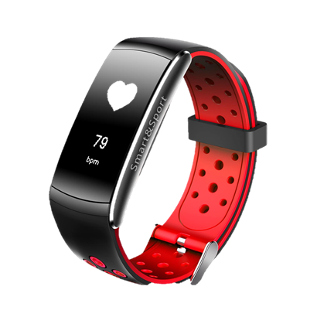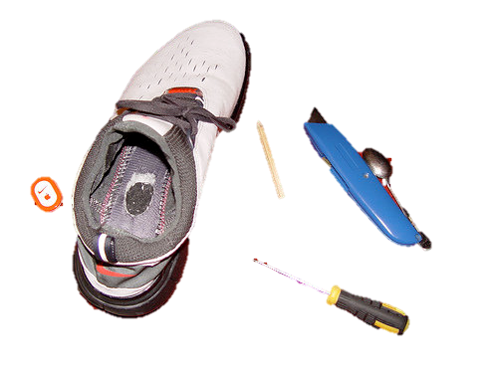

Figure 4.1 Figure 4.2

Users are required to wear the bracelet and install the in-shoe devices.

(show as Figure 4.1 & 4.2)

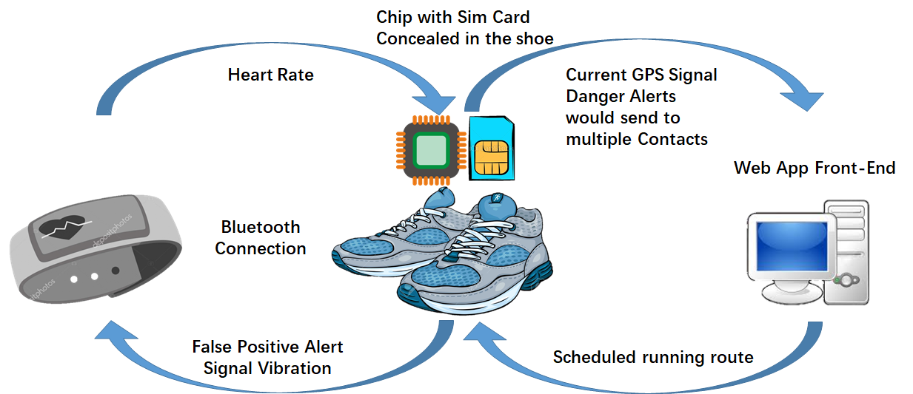

Figure 4.3

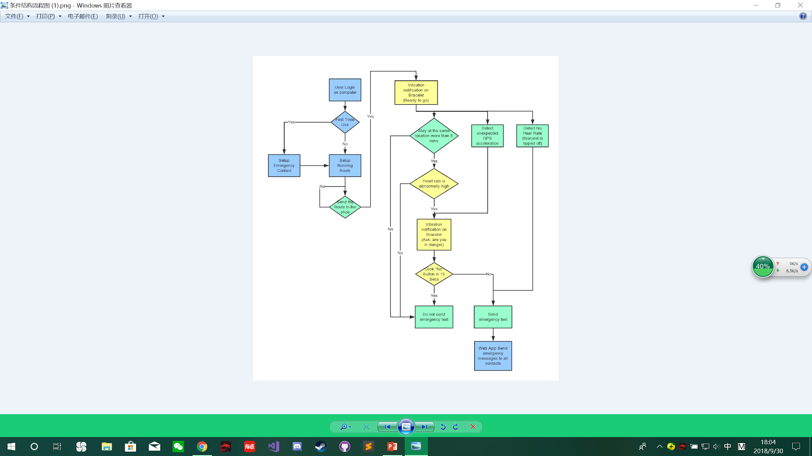

Figure 4.4

# 

# Competing Technologies

There are many products designed for protecting runner’s safety. We can simply get them on Amazon at a very low price, however, the comprehensiveness of functions and dangers that runners may encounter in different situations must be considered when designing these devices.

RunAngel is a personal safety wearable that looks much like a watch. It is a safety aid aimed at keeping joggers and cyclists safe. The device emits a very loud alarm to attract attention in an emergency. The RunAngel app gives peace of mind to family & friends who are alerted via SMS & email, showing the date, time and location of the wearer when their run angel is activated. Furthermore, it contains a rechargeable battery which is charged via a micro USB cable.

To activate it, user needs to press once on the centre button that shows the sound waves. To deactivate it, press the small circular on / off button on the shoulder of the strap. The alarm can also be cancelled direct from the app activation page.

SABRE designed a Runner Personal Alarm with Adjustable Wrist Strap, which has a piercing, 130dB alarm that calls for attention up to 1,000 feet away and helps scare off attackers. It is operated by pulling a metal ring. SABRE’s loud alarm is similar with one of the functions in RunAngel, and they both need to be activated by external force.

Unlike these two products mention above, our product would give runners a much more secure experience. Instead of pushing a button to activate the alert, our product can automatically detect the danger and take action immediately, sending GPS coordinates to an emergency contact, even under situations in which the runner has no ability to use the device. Moreover, our product can hide inside a runner’s shoes to make sure it won't be left behind when in a dangerous situation.

# Engineering Requirements

Functions: The primary function intended for our device is to detect when a runner is in distress due to a dangerous or unexpected emergency. Examples of this could involve the user facing a health emergency, kidnapping, or any other emergency causing the user to be in danger. This will be detected by measuring specific objectives the device will monitor. Our device consists of two parts, one being a wrist band for the user to communicate through and a shoe insert that helps monitor data.

Objectives:

* GPS Tracking
  + Use of a small GPS module implemented into the shoe insert
  + Strip GPS from existing product, and re-program for our device
* Heart Rate Monitor
  + Programmed into wristband to monitor heart rate for abnormal spikes or drops
  + Specifically track for quick/steep increases due to adrenaline rush
* Accelerometer
  + Part of shoe insert to measure acceleration of runner
  + Set maximum to be ~20 mph (still debating)
  + Measure time spent at certain pace
* Calling/Outreach System
  + Programmed into web app but connected through wristband
  + Calls/Texts programmed emergency contact with GPS location and alert

Constraints:

* Not Easily Detectable
  + Shoe insert is hidden in shoe
* Very Small/Light in Weight
  + < 100g for wristband and shoe insert (individually)
* Sturdy/Strong
  + Shoe Insert - survive pressure from running on feet
* Cost
  + Limit = $1000
  + Goal: Cheap as possible to achieve deliverables
  + Competing technologies ~$100
* Long Lasting Battery
  + Able to stay on for entire run length (6 hour battery life)
  + Rechargeable
* Easy to Use
  + Easy to program/set-up for users of all ages

# Appendix A References.

Fuller, Steve. “Topic: Running & Jogging.” Statista, 2016, [www.statista.com/topics/1743/running-and-jogging/](http://www.statista.com/topics/1743/running-and-jogging/).

“Run Angel.” Runangel, 2018, <https://runangel.com/products/run-angel>.

“Runner Personal Alarm with Adjustable Wrist Strap.” SABRE, 2018,

[www.sabrered.com/pepper-spray/runner-personal-alarm-adjustable-wrist-strap](http://www.sabrered.com/pepper-spray/runner-personal-alarm-adjustable-wrist-strap).